angularJs详解

# 1、js端取得字符串判断是否空值，防止后台接收不到数据（比较三个数值）

if ( $scope.remarkSettleData.remark == undefined ||

$scope.remarkSettleData.remark == null ||

$scope.remarkSettleData.remark == ''){  
 toastr.warning('请填写备注','提示');  
 return;  
}

# 2、angular .foreach

## 解释：AngularJS中当我们需要遍历某个数组的时候，我们会用到forEach语法。array表示需要遍历的数组，obj表示遍历时的每个元素，index表示遍历时元素的下标。index不是必须的参数，可以不写。可以根据需要添加与否。

angular.forEach(array,function(obj,index){

doSomething();

})

## 举例

$http.get(***ctx*** + '/skin/getLastCCAdmList?taskType=26')  
 .success(function (data, status) {  
 $scope.copyList = [];  
 if (data.success) {  
 if (data.result != null && data.result.length > 0) {  
 angular.forEach(data.result, function (obj, key) {  
 $scope.copyList.push(obj);  
 });  
 }  
 } else {  
 ngDialog.alert(data.message);  
 }  
 })  
 .error(function (data, status) {  
 ngDialog.alert('获取上次设置的抄送人失败');  
 });

# 3、push,给数组添加数据

$http.get(***ctx*** + '/skin/getLastCCAdmList?taskType=26')  
 .success(function (data, status) {  
 $scope.copyList = [];  
 if (data.success) {  
 if (data.result != null && data.result.length > 0) {  
 angular.forEach(data.result, function (obj, key) {  
 $scope.copyList.push(obj);  
 });  
 }  
 } else {  
 ngDialog.alert(data.message);  
 }  
 })  
 .error(function (data, status) {  
 ngDialog.alert('获取上次设置的抄送人失败');  
 });

# 4、注意初始化数据

$scope.query = {type:''};  
 $scope.skin = {};  
 $scope.add = false;  
 $scope.editFlag = false;  
  
 $scope.processing = false;  
  
*/*审核人和抄送人*/* $scope.approverList = [];  
 $scope.copyList = [];

# 5、join ,取出对象数组中的id值，制作为字符串，并使用，间隔 比如 "1,2,3,4"，之前是['a','b','c','d']

var apprList = [];  
angular.forEach($scope.approverList, function (value, key) {  
 apprList.push(value.id);  
});  
var ccList = [];  
angular.forEach($scope.copyList, function (value, key) {  
 ccList.push(value.id);  
});

$scope.skin.apprIds = apprList.join(',');  
$scope.skin.ccIds = ccList.join(',');

# 6、ngDialog.alert 警告框

# 7、toastr.success操作成功以后，在浏览器的右方显示成功

## 1、操作成功展示

toastr.success('操作成功','提示');

### 页面展示

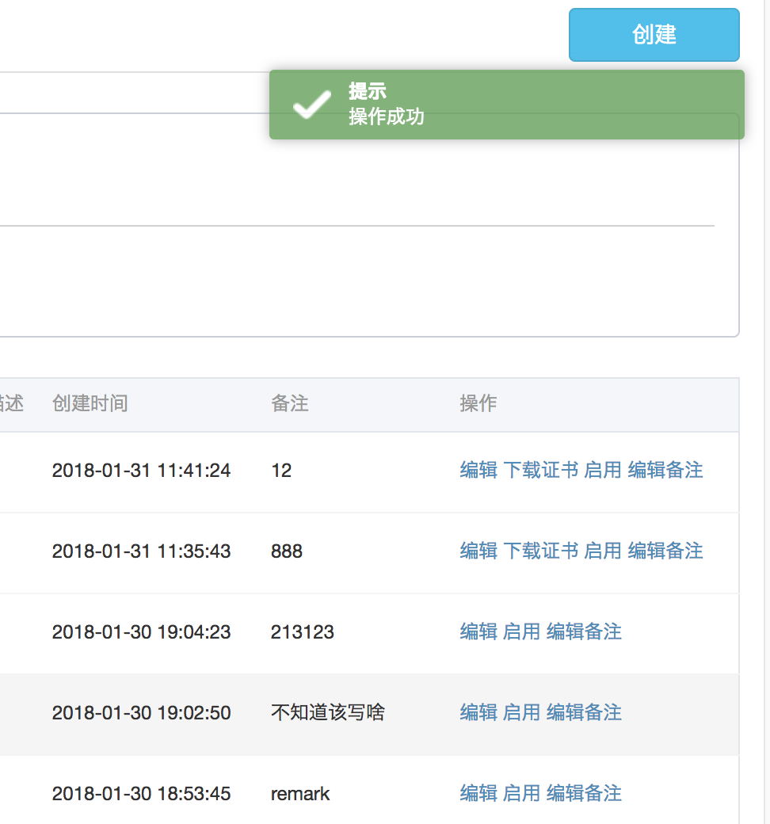

# 2、操作失败展示

toastr.error('加载权限角色数据失败','提示');

# 3警告

toastr.warning('您每次最多只能设置15个参数','提示');

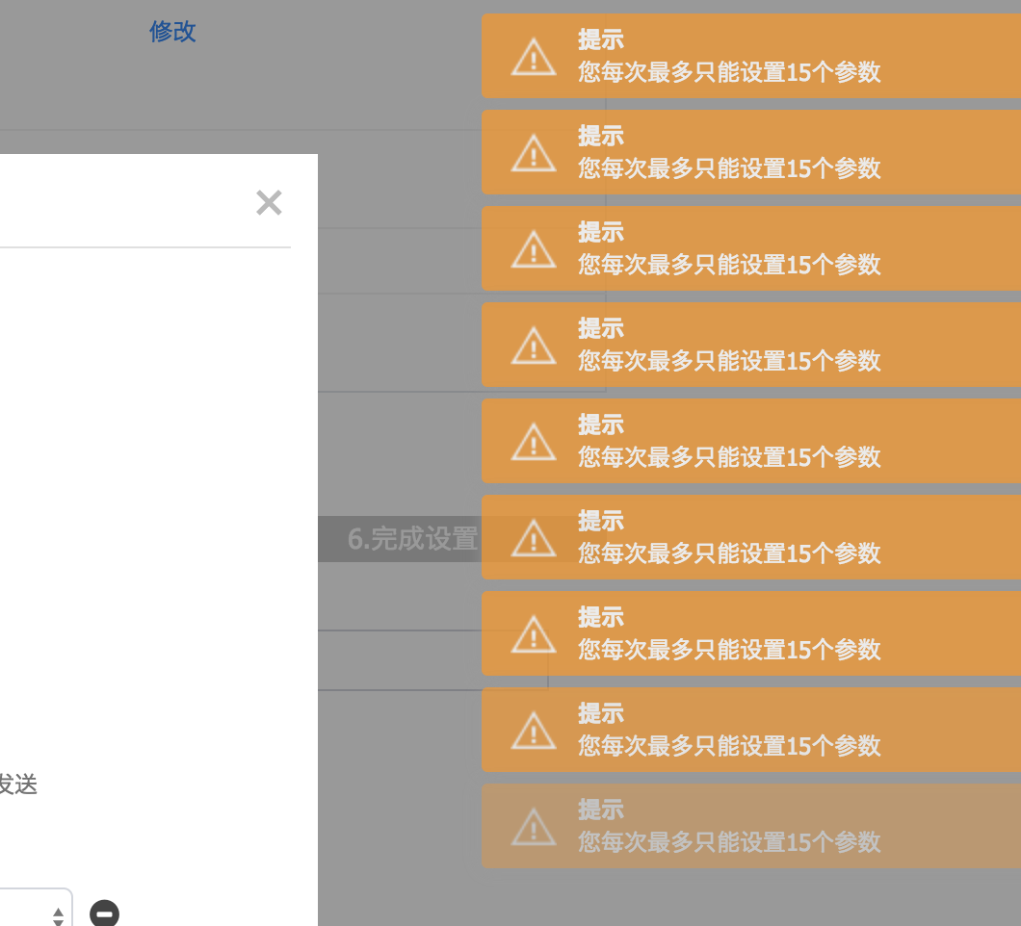

# 8、$watch,（时间间隔）用来监视其中的变量，下面的代码不全哦，只是说明下$watch用法

$scope.$watch('olduserListOutputModel.outputData[0]', function() {  
 for(var i= 0;i< $scope.olduserList.length ;i++){  
 if($scope.olduserList[i].customerId==$scope.olduserListOutputModel.outputData[0].customerId){  
 $scope.query.balance = $scope.olduserList[i].balance ;  
 }  
 }  
  
});

# 9、ng-if

<div class="form-group" ng-if="skin.type != 5 && skin.type != 6">  
 <label class="col-sm-2 control-label"><span class="danger">*</span>苹果ID：</label>  
 <div class="col-sm-8">  
 <input name="trackId" ng-model="skin.trackId" type="text" class="form-control" required/>  
 </div>  
</div>  
<div class="form-group" ng-if="skin.type != 5 && skin.type != 6">  
 <label class="col-sm-2 control-label"><span class="danger">*</span>bundleId：</label>  
 <div class="col-sm-8">  
 <input name="bundleId" ng-model="skin.bundleId" type="text" class="form-control" required/>  
 </div>  
</div>  
<div class="form-group" ng-if="skin.type != 5 && skin.type != 6">  
 <label class="col-sm-2 control-label"><span class="danger">*</span>scheme：</label>  
 <div class="col-sm-8">  
 <input name="scheme" ng-model="skin.scheme" type="text" class="form-control" required/>  
 </div>  
</div>

# 10、ng-selected ng-checked（ng-show 其实也是这样的）

<select ng-model="target.method" class="form-control" style="width: 73px;float: right;">  
 <option value="1" ng-selected="target.method==1">GET</option>  
 <option value="2" ng-selected="target.method==2">POST</option>  
</select>

<input type="checkbox" ng-checked="item.checked==true" name="channel" value="{{***item***.value}}" ng-click="selectChannel(item)">

# 11、点击时间弹出一个页面

## 1、页面内容

<script type="text/template" id="clickConfigInfo">  
  
 <h5>{{***name***}}</h5>  
 <div class="divider"></div>  
  
   
</script>

## 2、ngDialog.open( js控制打开弹窗页面

ngDialog.open({  
 template: $('#clickConfigInfo').html(),  
 width:'900px',  
 plain:true,  
 cache:false,  
 scope: $scope  
});

## 关闭用 ngDialog.close();

# 12、angular.copy 同一页面编辑列表详情(其实是去除数组中的//去掉$$hashKey属性 )

$scope.edit = function(item) {  
 $scope.skin = angular.copy(item);  
 $scope.add = false;  
 $scope.editFlag = true;  
};

# 13、json 数组的转化

## 1、将json数组转化为json字符串，后台String接收

$scope.json =angular.copy($scope.channelLists); //去掉$$hashKey属性  
 var channelJson = angular.*toJson*($scope.json);

$scope.skin.channelJson = new ***FormData***();  
 $scope.skin.channelJson = channelJson;

## 3、将后端传来的josn字符串解析成json 数组$scope.channelLists为josn数组 []

$scope.edit = function(item) {  
 $scope.skin = angular.copy(item);  
 if($scope.skin.channelJsonList.length>0){  
 $scope.channelLists = angular.*fromJson*(item.channelJson) ;  
 }else {  
 $scope.channelLists = $scope.channelListsEmpt; //临时数组  
 }  
 $scope.add = false;  
 $scope.editFlag = true;  
};

# 14、json数组的遍历

## 1、判断后端的List集合的长度 ($scope.skin.channelJsonList.length

if($scope.skin.channelJsonList.length>0){  
 $scope.channelLists = angular.*fromJson*(item.channelJson) ;  
  
 for(var i = 0;i <$scope.channelLists.length;i++){  
 if($scope.channelLists[i].checked==true){  
 $scope.channelListsEnable.push($scope.channelLists[i]);  
 }  
 }  
 $scope.enableItem=item;  
 ngDialog.open({  
 template: $('#enableDialog').html(),  
 width:'650px',  
 plain:true,  
 scope: $scope,  
 cache:false,  
 name:'enableDialog',  
 showClose:false  
 });  
}else {  
 return;  
}

# 15、前台格式的转化

## 1、金额

<td>{{***item***.money|currency:'￥':2}}</td>

## 2、日期

<p class="info">  
 <label>联系日期</label>  
 <span class="des">{{currItem.contactTime|*date*:'yyyy-MM-dd'}}</span>  
</p>

# 16、隐藏 ng-hide ng-show ==true或者是false

<div class="col-md-6 col-sm-12" ng-hide="true">